**SPIRIT FIELDS RESIDENTIAL DEVELOPMENT**

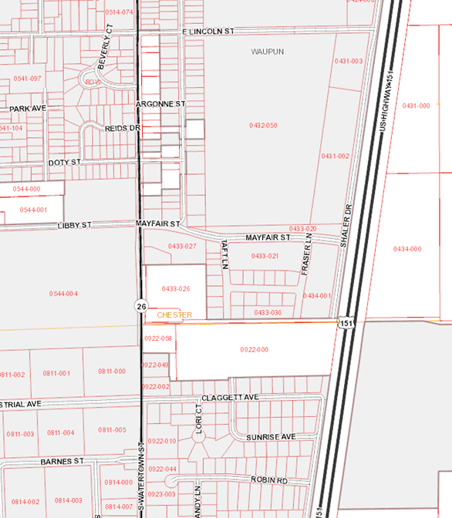

Spirit Fields is located in Mayfair Estates on city-owned land on the southeast side of the City of Waupun. The City is seeking bids for land sales for construction of Spirit Fields to begin Quarter 2 of 2020. The development contains 5 parcels zoned R2 for single and 2-family residential development.

Waupun JR/SR High School

* Quick access to US 151
* Waupun Area School District
* Fully Improved Lots (Spring 2020)

**DEVELOPMENT OPPORTUNITY:**

Tax Increment Financing is being used to fund the construction of this project. Tax increment generated will pay 100% of the project costs related to public infrastructure improvements in TID 5 along the US 151 corridor. The city is currently seeking developers for residential construction projects on the five lots. See attached plat for site/location details. The City has established a land price to leverage tax increment financing and foster early development and will entertain offers from developers who are fully capitalized for the proposed project. Effective July 11, 2019, land price for each available lot starts at $15,000 with a commitment to complete construction and obtain occupancy by December 31, 2020. The City will special assess an additional $5,000 to the parcel for a total land sale of $20,000 for any parcel sold that does not complete construction and obtain occupancy granted as of December 31, 2020.

Developers awarded a purchase agreement will be subject to the restrictive covenants of the subdivision and will be required to sign a developer’s agreement with the City of Waupun. The initial deadline to respond is **July 31, 2019** but may be extended at the discretion of the City of Waupun. To be considered, developers should submit a written offer to purchase along with evidence of financing and a description of the intended project to be built on the site in a sealed envelope and marked to the attention of the City Clerk, City of Waupun, 201 E Main Street, Waupun, WI 53963 by 4:30 p.m. on July 31, 2019.

Contractors awarded purchase agreements will have 30 days to sign a developer’s agreement and schedule closing with the City of Waupun. Offers failing to meet the 30 deadline will be considered null and void and the next competitive bidder will be selected. Other proposals to foster development on this land may be considered at the city’s discretion. The city will select the highest use of the land when considering purchase offers from the pool of qualified developers by no later than August 13, 2019.

Questions may be directed to Kathy Schlieve, City Administrator/Director of Economic Development, at the City of Waupun by emailing [Kathy@cityofwaupun.org](mailto:Kathy@cityofwaupun.org) or by calling 920.324.7912.